Tortoise Git Installation

Software installation

1. Go to URL: <https://tortoisegit.org/>



1. Download latest version of Tortoise Git for your architecture (64 bit)

<https://download.tortoisegit.org/tgit/2.5.0.0/TortoiseGit-2.5.0.0-64bit.msi>

1. After downloading run installer executable (TortoiseGit-2.5.0.0-64bit.msi)
2. Use default installation location. Use default components and settings for installation.

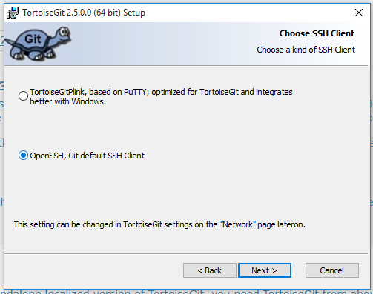

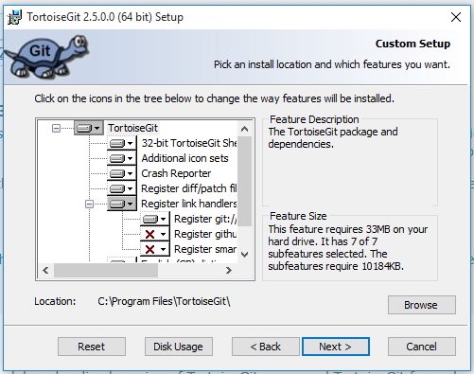

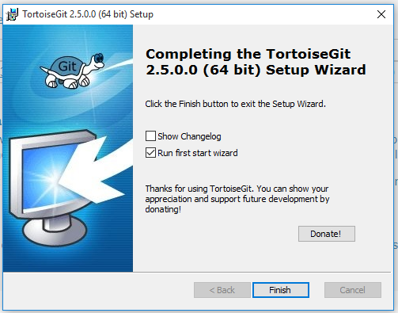

1. After installation is done run first start setup wizard.

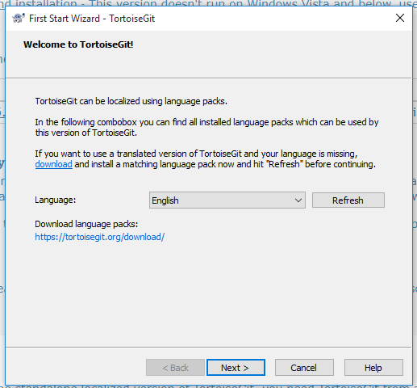

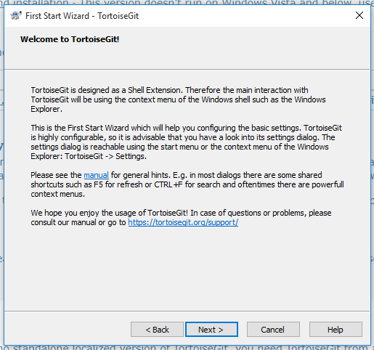

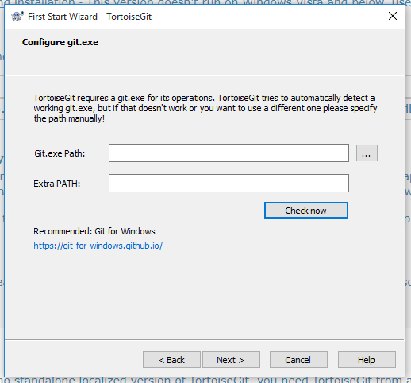

1. At this point Git for Windows has to be installed, otherwise wizard can’t proceed any further. After installation wizard will find git.exe location automatically.

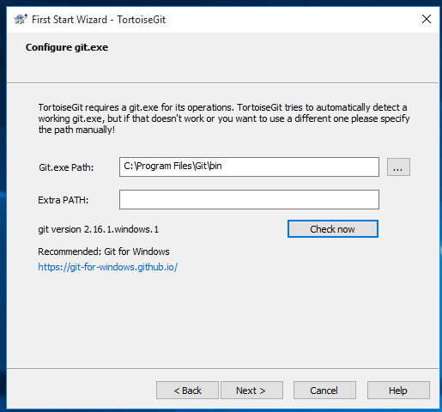

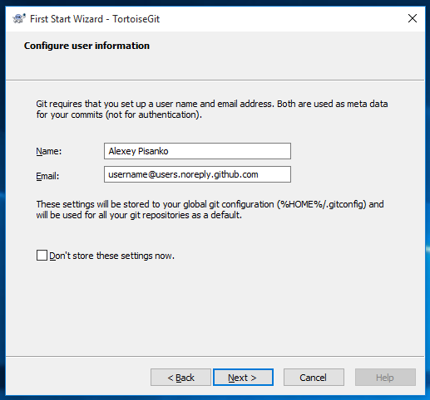

1. It is recommended to specify your email address as **github_username**@users.noreply.github.com where github_username is your username on github server. This way your real email address is not committed into git repository with each checkin.

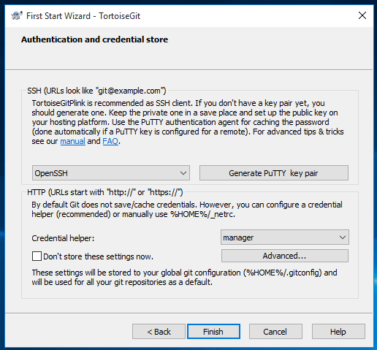

1. Finish your installation.